- Serial Peripheral Interface Bus
- From Wikipedia, the free encyclopedia
Jump to: navigation, search
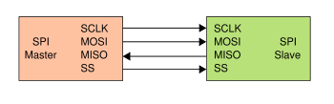
SPI bus: single master and single slave
The Serial Peripheral Interface Bus or SPI (often pronounced like "spy") bus is a synchronous serial data link standard designed by Motorola that operates in full duplex mode. Devices communicate in master/slave mode where the master device initiates the data frame. Multiple slave devices are allowed with individual slave select (chip select) lines.

Contents
[hide]
- 1 Interface
- 2 Operation
  - 2.1 Transmission
  - 2.2 Clock polarity and phase
    - 2.2.1 Modes
- 3 Pros and cons of SPI
  - 3.1 Advantages
  - 3.2 Disadvantages
- 4 Daisy chain SPI configuration
- 5 Applications
- 6 Similar protocols
  - 6.1 Queued Serial Peripheral Interface (QSPI)
- 7 Standards
- 8 See also
- 9 External links

[edit] Interface
The SPI bus specifies four logic signals.
- SCLK — Serial CLocK (output from master)
- MOSI — Master Output, Slave Input (output from master)
- MISO — Master Input, Slave Output (output from slave)
- SS — Slave Select (active low; output from master)
Sometimes, the following naming convention is used:
- SCLK — Serial CLocK (output from master)
- SDI — Serial Data In
- SDO — Serial Data Out
- CS — Chip Select (active low; output from master)
The latter convention requires that SDO on the master be connected to SDI on the slave, and vice-versa.
SPI port pin names for particular IC products may differ from those depicted in this illustration.

[edit] Operation
The SPI bus can operate with a single master device and with one or more slave devices.
If a single slave device is used, the SS pin may be fixed to logic low if the slave permits it. Some slaves require the falling edge (high->low transition) of the slave select to initiate an action such as the MAX1242 by Maxim IC, an ADC, that starts conversion on said transition. With multiple slave devices, a independent SS signal is required from the master for each slave device.
Most devices have tri-state outputs that become high impedance ("disconnected") when the device is not selected.
- [edit] Transmission
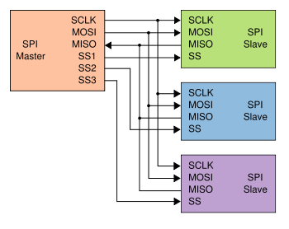
SPI bus: single master and three slaves
To begin a communication, the master pulls the slave select low for the desired chip. If a waiting period is required (such as for analog-to-digital conversion) then the master must wait for at least that period of time. The master then generates a clock frequency less than or equal to the maximum frequency the slave device supports (this is usually configured in the master on a per-transmission basis). During clock generation, a full duplex transmission occurs:
- the master sends data on the MOSI line; the slave reads from the MOSI line
- the slave sends data on the MISO line; the master reads from the MISO line
Not all transmissions require all four of these operations to be meaningful but they do happen. Generally, a transmission happens in single byte increments and a master can initiate multiple 8-bit transmissions if it wishes/needs.
Every other slave on the bus that doesn't have their slave select line pulled low must disregard the clock, MOSI, and MISO lines.
- [edit] Clock polarity and phase
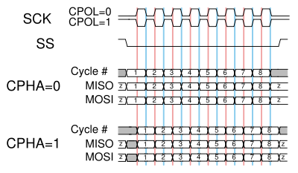
A timing diagram showing clock polarity and phase
In addition to setting the clock frequency, the master can set the clock polarity and clock phase with respect to the data. For example, the LPC2104/2105/2106 (a ARM7TDMI 60 MHz microcontroller) names these two options as CPOL and CPHA.
The timing diagram is shown to the right and described below:
- At CPOL=0 the base value of the clock is zero
  - For CPHA=0, data is read on the clock's rising edge (low->high transition) and data is changed on a falling edge (high->low clock transition).
  - For CPHA=1, data is read on the clock's falling edge and data is changed on a rising edge.
- At CPOL=1 the base value of the clock is one (inversion of CPOL=0)
  - For CPHA=0, data is read on clock's falling edge and data is changed on a rising edge.
  - For CPHA=1, data is read on clock's rising edge and data is changed on a falling edge.
This adds more flexibility to the communication channel between the master and slave.

[edit] Modes
The combinations of polarity and phases are often referred to as modes. The common convention for these four modes:
Mode | CPOL | CPHA
0 | 0 | 0
1 | 0 | 1
2 | 1 | 0
3 | 1 | 1

[edit] Pros and cons of SPI
- [edit] Advantages
- Full duplex communication for higher throughput
- Higher throughput than I²C
- No addressing means reduced overhead which can be advantageous in small number (if not single) slaves
- [edit] Disadvantages
- Requires more pins on IC packages:
  - Half duplex would require one fewer pin
  - No addressing requires chip selects
- No hardware flow control
- No slave acknowledgment (the master could literally be "talking" to nothing and not know it)
- Is not a multi-master bus

[edit] Daisy chain SPI configuration
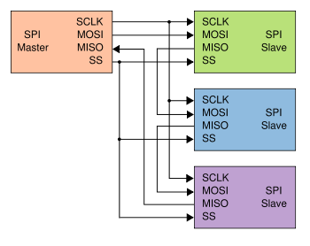
SPI bus: one master and three daisy-chained slaves
Some products with SPI bus are designed to be capable of being connected in a daisy chain configuration, the first slave output being connected to the second slave input, etc. The SPI port of each slave is designed to send out during the second group of clock pulses an exact copy of what it received during the first group of clock pulses. The whole chain acts as an SPI communication shift register. Such a feature only requires a single SS line from the master, rather than a separate SS line for each slave.

[edit] Applications
The SPI full-duplex capability make it very simple and efficient for single master/single slave applications. The complexity of the interface grows as the number of slave devices increases due to its lack of built-in addressing. Some devices use the full-duplex mode to implement an efficient, high-speed data stream for applications such as digital audio, digital signal processing, or telecommunications channels.
In practice, many devices have exceptions. Some read data as SCLK goes high, and others read data as SCLK goes low. Sending data from slave to master is almost always during the opposite clock level as master to slave. Some devices have two clocks, one to "capture" or "display" data, and another to clock it into the device. Many of these "capture clocks" can be run from the SS line.

[edit] Similar protocols
- [edit] Queued Serial Peripheral Interface (QSPI)
 | Please help improve this article by expanding this section.  Further information might be found on the talk page or at requests for expansion. Please remove this message once the section has been expanded.

[edit] Standards
The SPI bus is a sort of de facto standard, rather than one agreed by any international committee. The reason for this is probably its essential simplicity.

